PHISHING EMAIL DETECTION & AWARENESS SYSTEM
Future Interns – Cyber Security Internship
Submitted By
VIBHAVARI GOLI
CIN ID
FIT/JUN26/CS9221
Internship Domain
Cyber Security
Task Number
Task 2
Organization
Future Interns

TABLE OF CONTENTS
- Introduction
- Objective
- Tools Used
- Email Analysis
- Common Phishing Indicators
- Risk Assessment
- Prevention Guidelines
- Awareness Recommendations
9. Conclusion
10. References

1. INTRODUCTION
Phishing is one of the most common cyber-attacks used by cybercriminals to steal sensitive information such as usernames, passwords, banking details, and personal information. Attackers often impersonate trusted organizations and send fraudulent emails to trick users into revealing confidential information.
The purpose of this project is to analyze phishing emails, identify suspicious indicators, classify email threats, and spread awareness regarding email security practices.

2. OBJECTIVE
The objectives of this project are:
• Identify phishing emails and suspicious messages.
• Analyze characteristics commonly used in phishing attacks.
• Classify emails as Safe, Suspicious, or Phishing.
• Create awareness regarding email security.
• Recommend preventive measures against phishing attacks.

3. TOOLS USED
• Google Search
• Browser
• Email Samples
• Microsoft Word
• GitHub

4. EMAIL ANALYSIS
Subject: Urgent: Verify Your Bank Account
Classification: PHISHING
Analysis:
This email attempts to create urgency by informing the user that their bank account has been suspended. The email contains a suspicious link and requests immediate action. Such tactics are commonly used by attackers to steal banking credentials.
Risk Level: HIGH
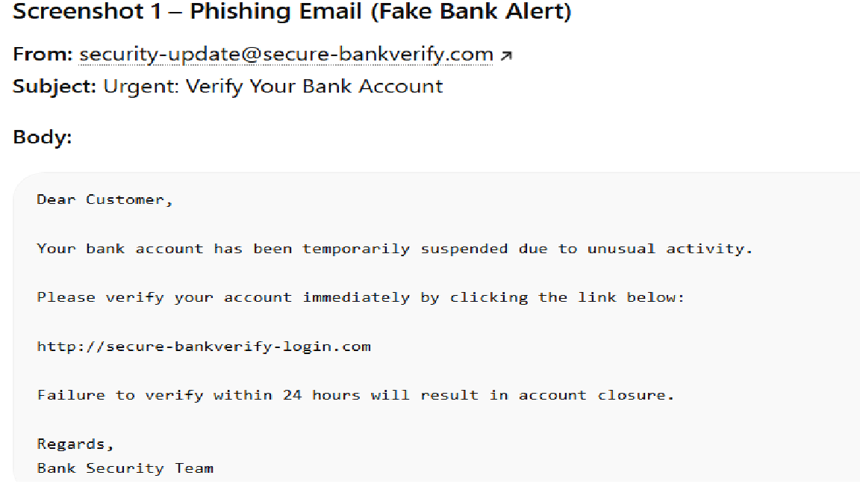

Subject: Password Reset Required
Classification: PHISHING
Analysis:
The email claims that the user's password is about to expire and provides a suspicious link for password reset. The sender domain appears fake and does not belong to the legitimate company.
Risk Level: HIGH
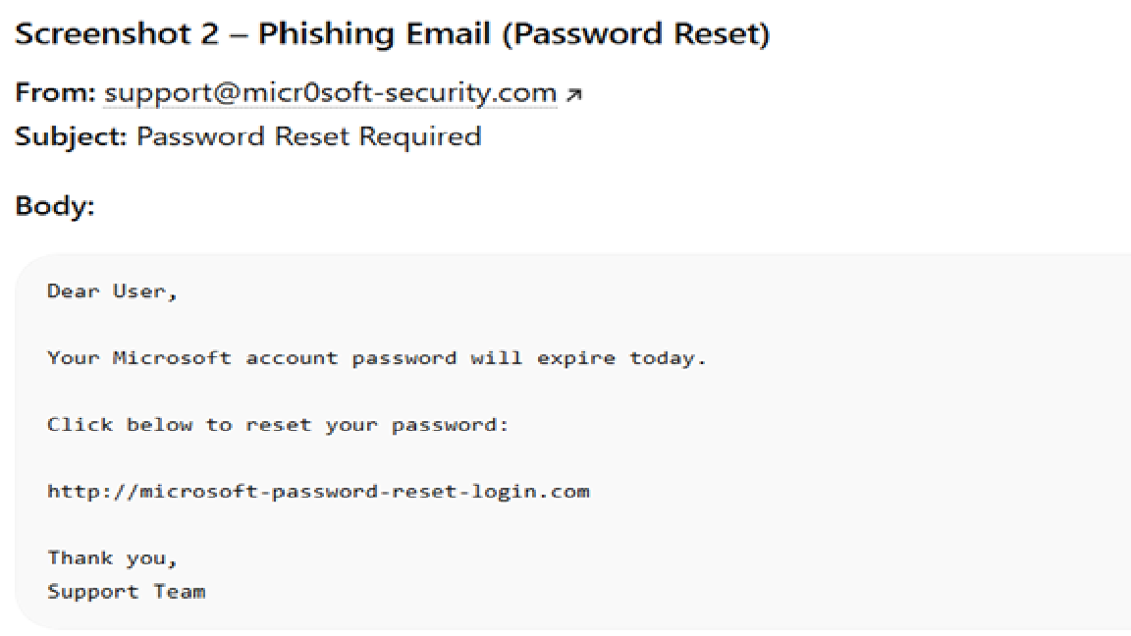

Subject: Invoice Attached
Classification: SUSPICIOUS
Analysis:
This email contains an unexpected invoice attachment from an unknown sender. Such emails are often used to distribute malware through malicious attachments.
Risk Level: MEDIUM
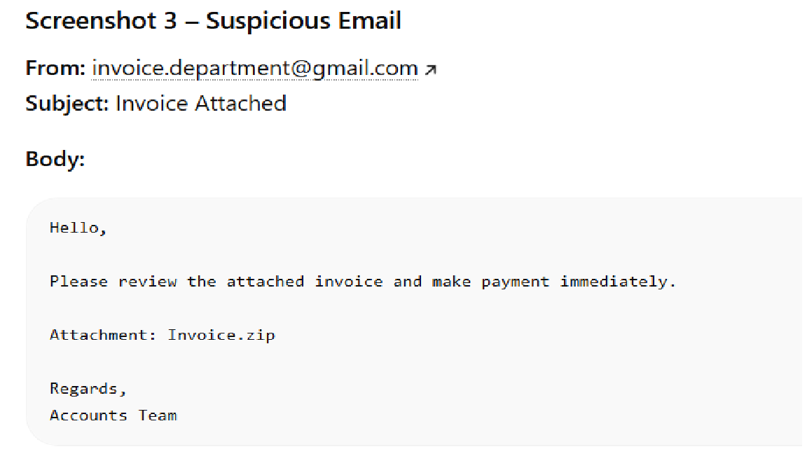

Email Sample 4
Subject: Interview Schedule
Classification: SAFE
Analysis:
The email is sent from a verified company domain and contains professional communication. No suspicious links or malicious attachments are present.
Risk Level: LOW

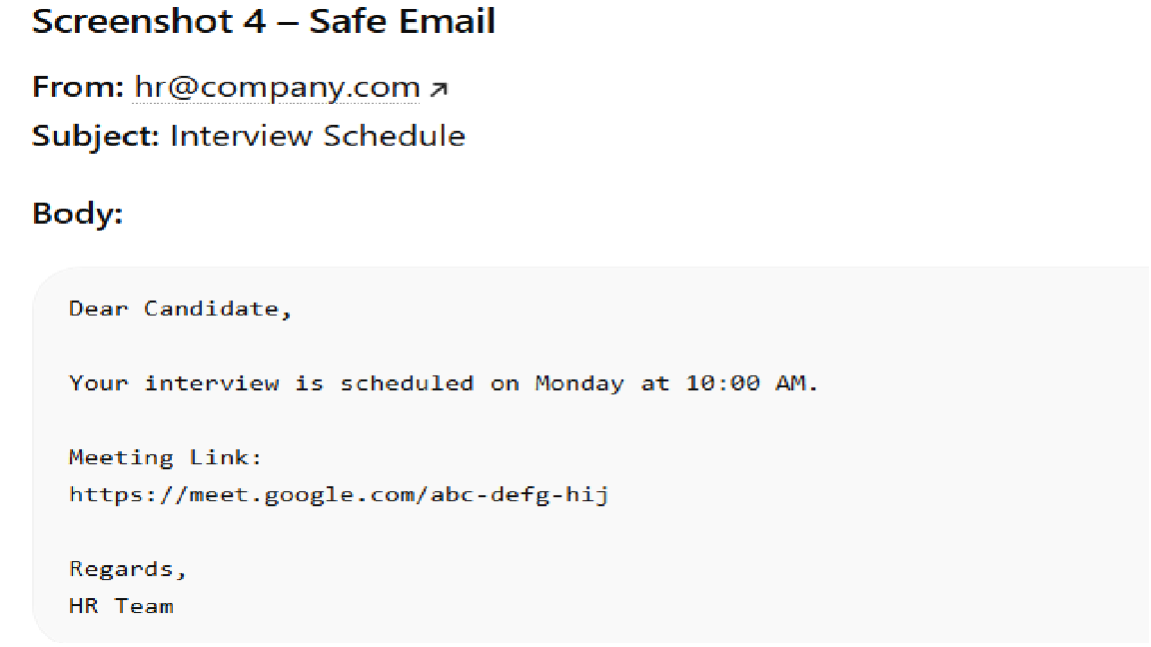

Email Sample 5
Subject: Project Meeting Update
Classification: SAFE
Analysis:
This email contains normal workplace communication from a known sender. The content is relevant and does not attempt to collect sensitive information.
Risk Level: LOW

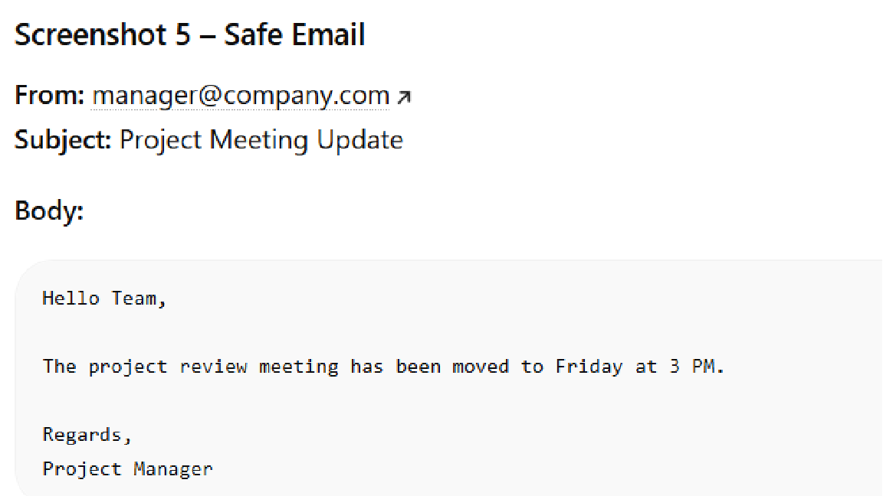

5. COMMON PHISHING INDICATORS
The following signs help identify phishing emails:
- Fake URLs
Attackers often create websites that closely resemble legitimate websites.
- Urgent Language
Messages create panic and force users to act quickly.
- Spelling and Grammar Errors
Many phishing emails contain poor grammar and spelling mistakes.
- Unknown Senders
Emails from unfamiliar sources should be treated cautiously.
- Suspicious Attachments
Unexpected attachments may contain malware.
- Requests for Sensitive Information
Legitimate organizations rarely request passwords or banking details through email.

6. RISK ASSESSMENT
Threat | Risk Level
Credential Theft | High
Malware Infection | High
Identity Theft | High
Financial Fraud | High
Data Leakage | Medium
The most significant risk associated with phishing attacks is credential theft, which may result in unauthorized access to personal or organizational accounts.

7. PREVENTION GUIDELINES
To protect against phishing attacks:
• Verify sender email addresses carefully.
• Avoid clicking unknown or suspicious links.
• Inspect website URLs before entering credentials.
• Use strong and unique passwords.
• Enable Two-Factor Authentication (2FA).
• Keep software and operating systems updated.
• Install trusted antivirus software.
• Avoid downloading unexpected attachments.
• Report suspicious emails immediately.
• Participate in cyber security awareness training.

8. AWARENESS RECOMMENDATIONS
Organizations should implement the following measures:
• Conduct regular cyber security awareness sessions.
• Deploy email filtering and anti-phishing solutions.
• Encourage employees to report suspicious emails.
• Establish incident reporting procedures.
• Monitor email communications for malicious activity.
• Perform regular security assessments.
These measures help reduce the risk of successful phishing attacks.

9. CONCLUSION
Phishing attacks continue to be one of the most common and dangerous cyber threats affecting individuals and organizations worldwide. Through this project, different email samples were analyzed and classified based on their characteristics and risk levels.
The analysis demonstrates the importance of identifying suspicious indicators such as fake links, urgent language, unknown senders, and malicious attachments. By following cyber security best practices and maintaining awareness, users can significantly reduce the risk of becoming victims of phishing attacks.
Continuous education, vigilance, and proper security controls are essential for maintaining a secure digital environment.

10. REFERENCES
- OWASP Security Guidelines
- Cyber Security Awareness Resources
- Google Security Center
- Public Phishing Email Samples
- Email Security Best Practices

